

**COLLEGE OF APPLIED SCIENCES AND PROFESSIONAL STUDIES CHIKHLI (CASPS)**

**VEER NARMAD SOUTH GUJARAT UNIVERSITY.**

BACHELOR OF COMPUTER APPLICATION(B.C.A)

(3RD YEAR / 6TH SEM)

**PROJECT REPORT ON**

" Online Learning Platform"

**GUIDED BY: SUBMITTED BY:**

**Pragnesh Desai Kumavat Nagesh L**

**Bhavsar Vivek P**

Acknowledgement

It is my proud privilege and duty to acknowledge the kind of help and guidance received from several people in preparation of this report. It would not have been possible to prepare this report in this form without their valuable help, cooperation and guidance.

First and foremost, I wish to record my sincere gratitude to management of this group and to our beloved **ic/PrincipIe Dr. Ashoksinh V. Solanki** for his constant support and encouragement in preparation of this report and for making available library and internet facilities needed to prepare this report.

Secondly, I express my sincere gratitude to my guide Pragnesh Desai for guiding rre in investigation for this seminar and in carrying out the work. My nurrerous discussions with him were extremely helpful. It helped me a lot to realize ofwhat we study for. I hold his in esteem for guidance, encouragement and inspiration received from him .

Thirdly, I would like to thank my parents, cousins & family who patiently helped me as I went through my work and helped to modify And eliminate some of the irrelevant or un-necessarY stuffs.

Next, I would like to thank my friends who helped me to make my work more organized and well-stacked till the end .

Last but clearly not the lesast would thank The Almighty for giving me Strength to complete m report on time.

Submitted by,

**Kumavat Nagesh L**

**Bhavsar Vivek**

Abstract

Online Learning Platform is a project which aims in developing an online application to provide Online Education, maintain Study Materials, keep Student records and collect Payments. This project has login features, Educator as Admin and Student as an user can login into their own portal separately. The Admin can login, through which the admin can monitor the whole system. This System can be used to search for course, add new courses, edit course, check payment status etc. The Admin after logging into his account can generate reports such as sell Report. The User can login into his account to follow course he purchased and can share his/her feedback.

Overall this project of ours is being developed to help the Educator (Admin) as well as Students (User) to provide Teaching-Learning platform in the best way possible.

Introduction

It is difficult to find time for the training necessary to gain new skills and boost your productivity. With Online Learning Platform you’re able to learn at a pace that is comfortable for you.Online Learning Platform is a powerful Learning Management System implementing the latest trends in e-learning. E-Learning is learning utilizing electronic technologies to access educational curriculum outside of a traditional classroom. In most cases, it refers to a course, or program delivered completely online. We define eLearning as courses that are specifically delivered via the internet to somewhere other than the classroom where the professor is teaching. E-Learning has been proven to be a successful method of training and education is becoming a way of life for many citizens in India and across the World. Online Learning Platform Publisher is a professional team development environment for the rapid development of e-courses by their own.

Any Person who wants to gain new skills can join Online Learning Platform. A Person/Student/Learner has to fill up registration form which is absolutely Free. Once Learner registers successfully, they will get UserID/Email and Password for login into Student/Learner Panel. After login they can buy any course as per their choice or requirement which is available in Online Learning Platform. They can watch purchased video courses online and can submit their feedback. As well they can update their profile and can change password. Admin of this system will upload new courses which will be available for everyone. Admin can delete or edit student/learner details. Admin can modify course details and can check sells report.

Objectives

A flexible web-based learning experience allows you to go through a guided curriculum or choose lessons on an as-needed basis. Following are the main objectives:-

* Ability to recall previously learned material – Students/learners can watch video courses as many times as they need. If they forgot something during the course they can come back and watch that specific part anytime.
* Creative way to present lesson – It is very creative way to present lectures. It will surely enhance teaching ability of tutor.
* Low Cost – As nobody needs to travel or rent anything so it’s very cost efficient.
* High Quality – As tutor do not has time boundation so he can teach in his own comfort time.
* Learn anytime from anywhere – Students/Learners can start learning anytime from anywhere they just required internet connection with a compatible device.
* Improve course quality according to learner’s feedback – Tutor can improve their course as per student’s feedback. It will help tutor to improve their ability to teach.
* Earn Money Online– As courses are paid so we can say it’s an online teaching business which has no boundaries means students/learners can join from across the world so this system can make good business with good quality.

Project Category

This project as titled “Online Learning Platform (E-Learning Management System)” is comes under the Web Based Application. This application is developed with the help of HTML, CSS, Bootstrap, PHP, MySQL etc.

**Web Based Application**

Tools/Platform

**5.1 Hardware Requirements**

|  |  |
| --- | --- |
| Processor | 1.6 GHz or Faster Processor |
| RAM | 8 GB |
| Disk Space | 80 GB of Available Hard Disk |
| Display | 1024 X 768 or Higher Resolution |

**5.2 Software Requirement**

|  |  |
| --- | --- |
| Operating System | Windows 11 |
| Front End | HTML, CSS, JavaScript |
| Back End | PHP |
| Library/ Framework | Bootstrap, JQuery, FontAwesome |
| Plugins | Owl Carousel |
| Code Editor | Visual Studio Code |
| Database | MySQL |
| Web Server | Apache |
| Web Browser | Google Chrome |

Reason of using PHP and MySQL

**PHP**

PHP is an open source language and all its components are free to use and distribute. PHP is server-side scripting language. It is embedded in HTML source code. PHP supports all major web servers such as Apache, Microsoft IIS and Netscape etc. All the major database such as Mysql, PostgreSQL, Oracle, Sybase, Microsoft SQL Server is supported by PHP. Following are the some major advantage:-

* Friendly With HTML - PHP and HTML are interchangeable within the page. You can put PHP outside the HTML or inside.
* Interactive Features - PHP allows you to interact with your visitors in ways HTML alone can't.
* Top-Notch Online Documentation - The PHP documentation is the best on the web. Hands down.
* Compatible With Databases - A good benefit of using PHP is that it can interact with many different database languages including MySQL.

**MySQL**

MySQL is the most popular open source relational database management system. It is one of the best RDBMS being used to develop web-based applications. It is easy to use and fast RDBMS. Following are the top reason to use MySQL:-

* High Performance
* Robust Transactional Support
* Strong Data Protection
* Open Source Freedom

Data Flow Diagram

Data flow diagram is graphical representation of flow of data in an information system. It uses defined symbols like rectangles, circles and arrows, plus short text labels, to show data inputs, outputs, storage points and the routes between each destination.

**1} DFD 0 Level**

The 0 Level DFD shows flow of data of application. DFD Level 0 is also called a Context Diagram. It’s a basic overview of the whole system or process being analyzed or modeled.

Buy Course

Upload Course

Student/Learner

Admin

Report

Watch Course

**O Level DFD**

**2} DFD 1 Level**

DFD Level 1 provides a more detailed breakout of pieces of the Context Level Diagram. This DFD describes main functions carried out by the system, as we break down the high-level process of the Context Diagram into its sub-processes.

**1 Level DFD**

retrieve

Authentic Status

feedback

update

submit

update

update

view

retrieve

retrieve

retrieve

update

lesson

course

student

Admin/Student

Admin

Authentic Status

Authentic Status

Authentic Status

Authentic Status

Student

Authentic Status

courseorder

**3 DFD 2 Level**

The DFD 2 Level describes flow of data in more detail. DFD Level 2 goes one step deeper into parts of Level 1. It may require more text to reach the necessary level of detail about the system’s functioning.

Authentic Status

update

Add, Remove, Edit

success

course

Entity Relationship Diagram (ER-Diagram)

An Entity Relationship Diagram (ERD) is a visual representation of different entities within a system and how they relate to each other.

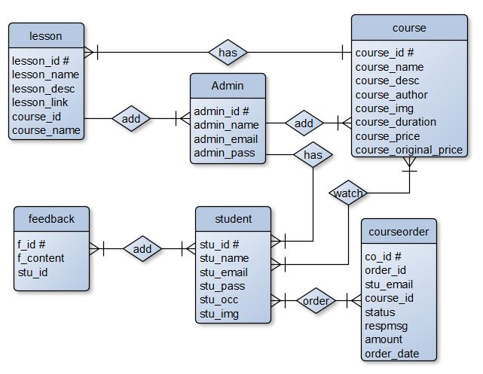

**ERD**

Flow Chart

A flowchart is a diagram that depicts a process, system or computer algorithm. They are widely used in multiple fields to document, study, plan, improve and communicate often complex processes in clear, easy-to-understand diagrams.

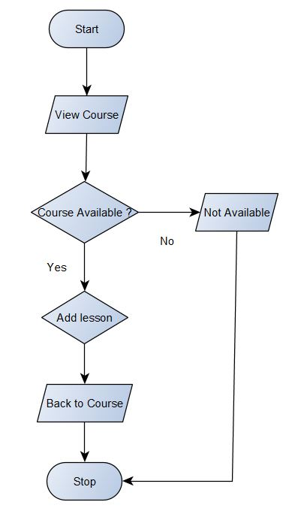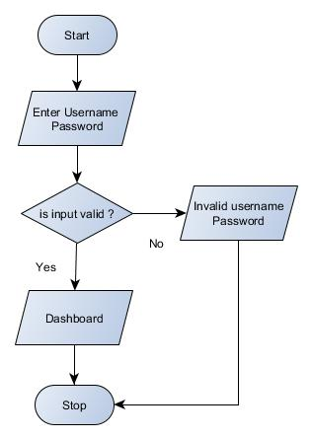

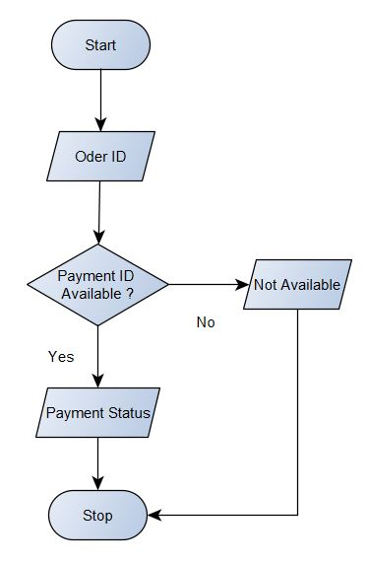

**Login**

**Add Lesson**

**Payment StatuP payment Status**

Input/ Output Modules of the Project

**1} Input Modules**

* Student/Learner Registration
* Course
* Lesson
* Feedback
* Payment Status

**2} Output Modules**

* Student/Learner List
* Course Detail
* Lesson Detail
* Sell Report
* Payment Receipt

Modules and Their Description

**Without Registration**

Home – This module contains all the links of the application such as Courses, Payment Status, Login, Sign Up, Feedback Section and Contact.

Courses – This module contains list of all the courses which are available at Online Learning Platform.

Payment Status – This module is used to check Payment status after purchasing a course.

Login – This module is used to login into Student/Learner Panel.

Sign Up – This module is used to register for the Student/Learner Panel.

Feedback – This section shows feedback given by registered students/learners.

Contact – Learner can use this section to contact the admin/tutor for any kind of queries.

**Student Panel**

Profile – This module contains all the details about Student/Learner as well as Student can update their details.

My Courses – This module contains list of all purchased courses.

Feedback – This module is used to write feedback.

Change Password – Students can use this module to change password.

Logout – This module is used to return back to Home Page.

**Admin Panel**

Dashboard – This module displays overview of whole application.

Courses – This module contains all the courses.

Lessons – This module contains all the lesson depends on course id.

Students – This module displays all the registered student details.

Sell Report – This module is used to view and print sells report.

Payment Status – This module displays payment status in more details.

Feedback – This module displays feedback given by students.

Change Password – Admin can use this module to change password.

Logout – This module is used to return back to Home Page.

Process Logic

**Home:**

When the user click on this tab, it will display the other modules and pages of the website such as courses, payment status, login, sign up, popular section, feedback section, contact and admin login. This module will be used to display the brief introduction of the project and will show the title of the project.

**Courses:**

Student can view all available courses by clicking on courses tab where he can choose course according to his own interest and by clicking on a particular course, will display more details with lesson title of the course, if he wants to purchase he will be able to make payment (required login).

**Payment Status:**

After purchasing course student will be provided an order id which can be used to get the status of payment using Payment status tab. If student wants he can get print out of his payment status.

**Login:**

This is a login form. Student/Learner can use their own email and password to login into the student panel.

**Sign Up:**

This is a Registration form for new Students/Learners. New Students/Learners can fill up the form for registration and after successful registration they can use their email id and password to login into the application.

**Feedback:**

This is very simple section which displays feedback given by the registered student.

**Contact:**

Learner can use this section to contact the admin/tutor for any kind of queries.

**Student Panel:-**

**Profile:**

Students/Learners can view their student id, registered email id, name, occupation, profile picture as well as they can modify and update the new data if they need.

**My Courses:**

Students can view all courses which they purchased. This is the place where they can start watching lectures by clicking on Watch Course button which leads to course playlist where they can watch the entire lesson of course.

**Feedback:**

Students can view/write feedback.

**Change Password:**

Students can use this module to change password.

**Logout:**

This module is used exit student panel and return back to Home Page.

**Admin Panel**

**Dashboard:**

This module displays overview of whole application such as number of course, number of registered students etc.

**Courses:**

This is the most important module of admin panel where Admin can view list of course as well as add new courses and modify or delete courses.

**Lessons:**

Admin can view lesson based on course id as well as new lesson can be added to the course and modification or deletion is also possible using this module.

**Students:**

Admin can view registered students details. Admin can add, edit and delete student.

**Feedback:**

Admin can view/delete feedback given by student.

**Sell Report:**

Analyzing sales is very import for any kind of business and this module is perfect for analyzing sales based on date. It will generate sells report which can be possible to print out for office records.

**Payment Status:**

If student file any complaints regarding payment Admin can use this module to display payment status in more details such as bank name, transaction id, payment date etc.

**Change Password:**

Admin can use change password.

**Logout:**

This module is used exit admin panel and return back to Home Page.

Limitations of the Project

* Only one tutor can access at a time
* It’s not SEO friendly
* Risk unauthorized accessibility
* Support is good in modern web browsers but not in legacy ones

Future Scope of the Project

* More than one tutor can be added
* Interaction between Student and Tutor can be improved by introducing Discussion forum
* Quiz Facility may enhance this application’s market value
* Live Class can be added

Bibliography

**Books: -**

* IGNOU Blocks of Systems Analysis and Design
* IGNOU Blocks of Introduction to Software Engineering
* The Complete Reference PHP
* Head First SQL: Your Brain on SQL by Lynn Beighley

**Web Source: -**

* www.google.co.in
* www.wikipedia.org
* www.php.net
* www.stackoverflow.com
* www.getbootstrap.com

Conclusion

The Online Learning Platform has been computed successfully and was also tested successfully by taking "Test Cases". It is user friendly, and has required options, which can be utilized by the user to perform the desired operations.

The Software is developed using HTML, CSS, JS as front end and PHP, MySql as back end in windows environment.

The goals that are achieved by the software are:

* Simplification of the operations
* Less processing time and getting required information
* User friendly
* Portable and flexible for further enhancement